HTML CSS

**Table of content**

* What is the definition of CSS?
* What is the difference between in HTML and CSS?
* How we can add CSS in HTML?
* What is inline CSS?
* What is internal and embedded?
* What is external CSS?
* CSS color, font, size?
* What is CSS border?
* What is CSS padding?
* What is CSS margin?
* How we can provide Link to External CSS?

**What is the definition of CSS?**

CSS is a cascading style sheet. In CSS, cascading means the style provided to the parent element is also apply on the element called as child element within the parent element. CSS is use for formatting the layout of your webpage. By using CSS, you can add different font sizes, different colors, background color, background images and many more. If you are using CSS and you set body color text then it will change overall color of your paragraph, heading of all the text element.

**What is the difference between in HTML and CSS?**

|  |  |
| --- | --- |
| **HTML** | **CSS** |
| HTML is a hypertext markup language used for designing your webpage. | CSS is a cascading style sheet which is used  For modifying designing and display of your HTML element. |
| While writing HTML document you can add CSS for formatting the web page | While creating CSS document you cannot add HTML in it. |
| HTML consists of tags. | CSS consists of sectors for declaration purpose. |
| HTML does not use any fixed method. | For implementation of the code CSS use three methods such as inline CSS, internal CSS, External CSS. |

**How we can add CSS in HTML?**

In HTML, we can add CSS in the HTML document by using three methods.

* Inline CSS
* Internal and embedded
* external CSS

**What is inline CSS?**

Inline attribute is a concept of adding style attribute in HTML element. While adding HTML attribute we need to add style attribute into the HTML start tag. Similar to the style attribute you can declare inline CSS in HTML document.

**Syntax-**

<html start tag style= attribute : value> your text <html end tag>

**Example-**

<html>

  <head>

    <title>inline css</title>

  </head>

  <body>

      <h1 style=" color: black; text-align: center; background-color: antiquewhite ;">GEEKY4U.com(Learn with passion)</h1>

    <h1

      style="font-size: x-large; text-align: center; color: rgb(13, 14, 12);"

    >

      GEEKY4U.com(Learn with passion)

    </h1>

  </body>

</html>

**Output-**

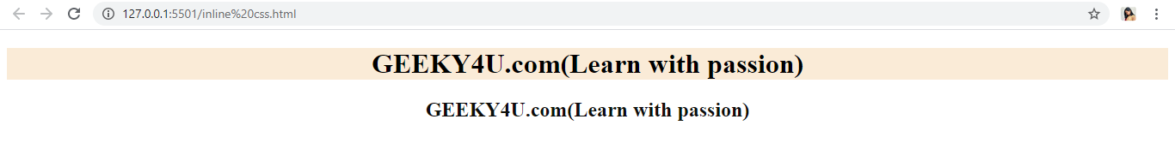

**What is internal and embedded?**

Internal tag is use for defining style on HTML page. This is use within the head section of the HTML document. For declaring internal CSS you need to create separate style tag outside the body tag. In the style tag you can add special attributes which is define and declare within two curly brackets along with start tag.

**Example-**

<!DOCTYPE html>

<html>

  <head>

    <title>internal style</title>

  </head>

  <style>

      h1 {background-color: rgba(226, 73, 99, 0.356)}

     h2 {color: rgb(88, 236, 175)}

  </style>

  <body>

    <h1>

      GEEKY4U.com(learn with passion)

    </h1>

    <h2>

      GEEKY4U.com(learn with passion)

    </h2>

  </body>

</html>

**Output-**

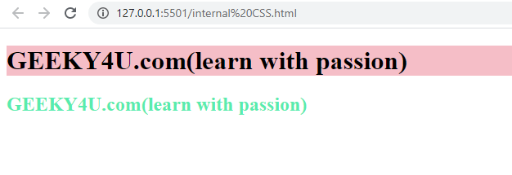

**What is external CSS?**

External style CSS is use for providing the style attribute through the link which is provided into the HTML head by using external style tag. HTML Style External style attribute is use for providing link into the head tag and by using this attribute HTML page will define style on different pages.

**Example-**

<!DOCTYPE html>

<html>

  <head>

    <title>external CSS</title>

    <link rel="stylesheet " href="style.html">

  </head>

  <body>

    <h1>GEEKY4U.com(learn with passion)</h1>

    <h2>GEEKY4U.com(learn with passion)</h2>

    <p>GEEKY4U.com(learn with passion)</p>

  </body>

</html>

**Output-**

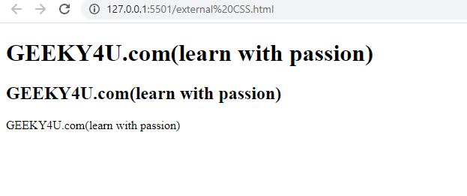

**CSS color, font, size?**

* CSS color is use for providing color to the text
* CSS font-family is use for providing different font style to your text.
* CSS font size is use providing font size to the text.

**Example-**

<!DOCTYPE html>

<html>

  <style>

      h1 {color: rgb(238, 39, 195);

      font-family: 'Times New Roman', Times, serif;

      font-size: x-large;}

     h2 {font-size: xx-large;

     color: rgb(12, 174, 238)}

  </style>

  <body>

    <h1>

      GEEKY4U.com(learn with passion)

    </h1>

    <h2>

      GEEKY4U.com(learn with passion)

    </h2>

  </body>

</html>

**Output-**

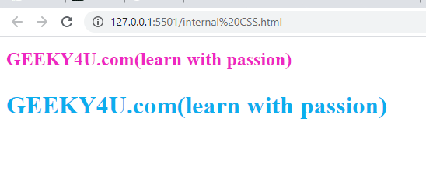

**What is CSS border?**

CSS border is use for providing border to your text.

NOTE: Most important thing about CSS border is you can give border to all the elements

**Example-**

<!DOCTYPE html>

<html>

  <head>

    <title>border color</title>

  </head>

  <style>

    h2 {

      text-align: center;

      border: 2px solid rgba(228, 37, 31, 0.644);

    }

</style>

<body>

    <h2>GEEKY4U.com(learn with passion)</h2>

    <h2>GEEKY4U.com(learn with passion)</h2>

  </body>

</html>

**Output-**

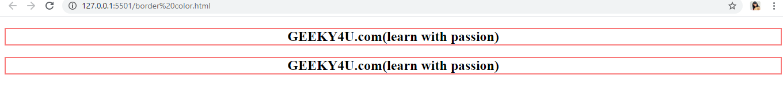

**What is CSS padding?**

CSS padding is also use for providing border to the text but padding is use for providing space between text and border.

**Example-**

<!DOCTYPE html>

<html>

  <head>

    <title>border color</title>

  </head>

  <style>

    h2 {

      text-align: center;

      border: 2px solid rgba(3, 39, 53, 0.644);

      padding: 1cm;

    }

  </style>

  <body>

    <h2>GEEKY4U.com(learn with passion)</h2>

    <h2>GEEKY4U.com(learn with passion)</h2>

  </body>

</html>

**Output-**

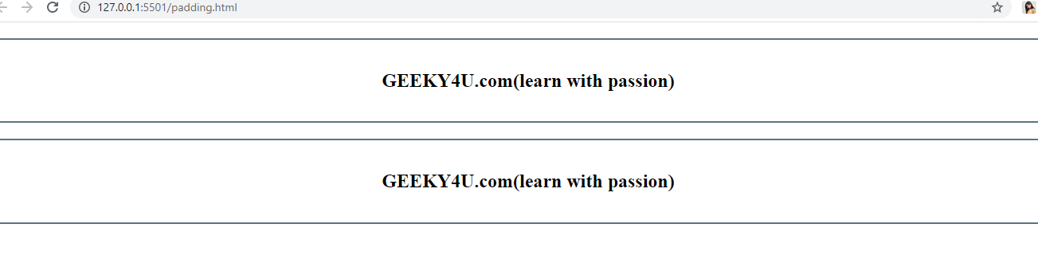

**What is CSS margin?**

CSS margin is use for providing margin to the border element.

**Example-**

<!DOCTYPE html>

<html>

  <head>

    <title>margin in border</title>

  </head>

  <style>

    h2 {

      text-align: center;

      border: 2px solid rgba(3, 39, 53, 0.644);

      padding: o.5cm;

      margin: 2cm;

    }

  </style>

  <body>

    <h2>GEEKY4U.com(learn with passion)</h2>

    <h2>GEEKY4U.com(learn with passion)</h2>

    <h2>GEEKY4U.com(learn with passion)</h2>

  </body>

</html>

**Output-**

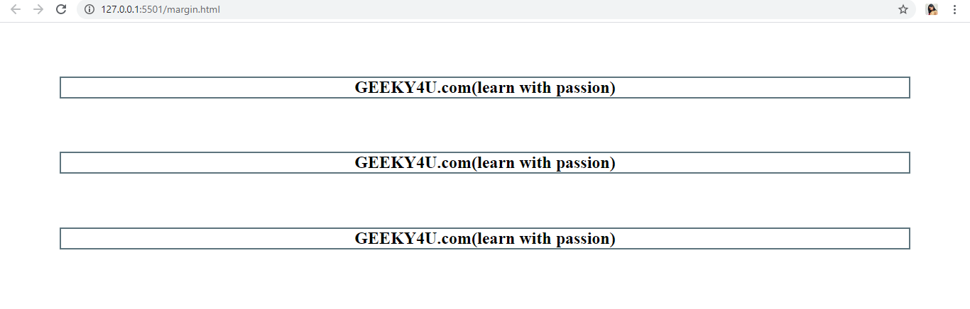

**How we can provide Link to External CSS?**

CSS External style attribute is use for providing link into the head tag and by using this attribute HTML page will define style on different pages.

**Example-**

<!DOCTYPE html>

<html>

  <head>

    <title>link </title>

    <link rel="stylesheet " href="style.html">

  </head>

  <body>

    <h1>GEEKY4U.com(learn with passion)</h1>

    <h2>GEEKY4U.com(learn with passion)</h2>

    <p>GEEKY4U.com(learn with passion)</p>

  </body>

</html>

**Output-**

